Project Status

1. **Problem:-**

Providing real rates of all vegetables and fruits to normal local peoples and make easier for government officials to inforce real rates whole over the country

1. **Abstract:-**

In many places fruits and vegetable sellers are selling these at their own rates And our government official has to do hard work to inforce these rates. Our proposed system will them both the locals and government officials. In our system we provide the real rate list directly from the DC office and the locals can see these rates on one touch.

1. **Group meeting:-**

Status: done

1. **Scope of the project:-**

The project initially targets our whole country and will be usable by all the locals and the government officials.

The projects can be generally categorized into three basic modules at the instant, namely:

Admin (Create, delete local admins. Change rates of any region)

Rates (Any person can see the rate list of any region)

Local Admin (Apply for local admin. Can only change rates of their own region)

# Status of the development of modules:-

Module:-

Admin:-

Sub-module:Login: completed

Create local admin: completed

Delete local admin: completed

See all local Admins: uncompleted

See local admin requests: completed

Update any region rates: completed

Local admin:-

Sub-modules:Login: completed

Update rates: completed

Apply for local admin: completed

Rates:-

Sub-modules:-

See rates of any region: completed

1. **Modules division**

|  |  |
| --- | --- |
| member | module |
| FA17-BCS-012 (Waleed Mustafa) | Rates, Local Admin |
| FA17-BCS-007 (Ali Haider) | Admin |

1. **UI Prototypes**

# Rates

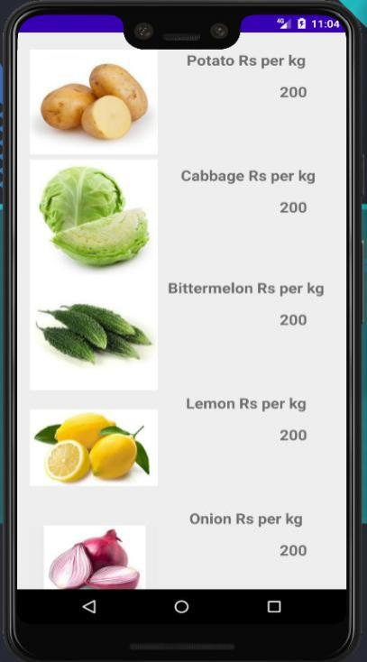

**Admin**

**login**

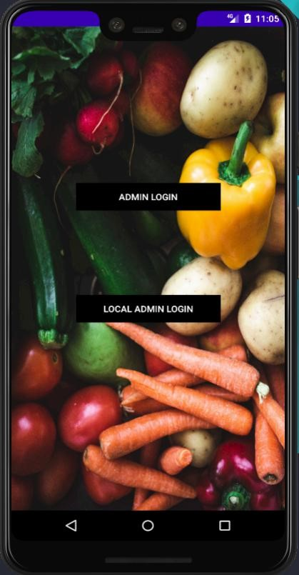

# Apply for local admin

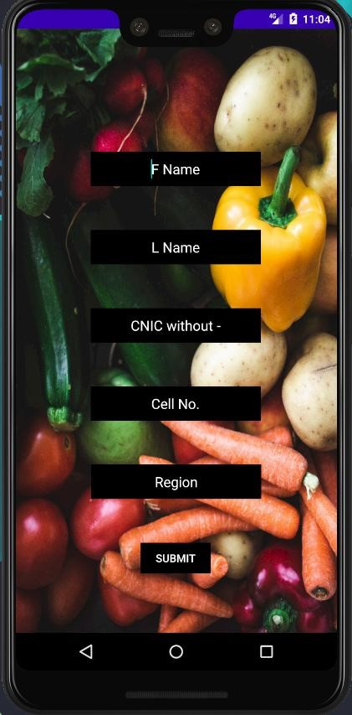

# Update rates

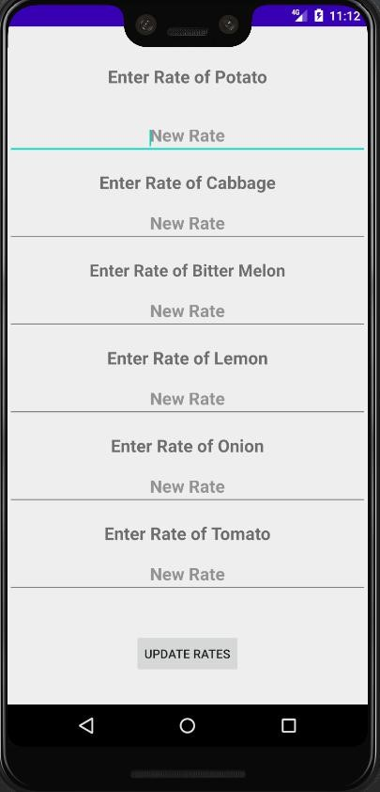

# Main page

